# Lab3- WAP for Usage of rules in Prolog.

Procedure:- Create a family tree program

* M is the mother of P if she is a parent of P and is female
* F is the father of P if he is a parent of P and is male
* X is a sibling of Y if they both have the same parent.
* Then add rules for grandparents, uncle-aunt, sister and brother .

Based on the facts, define goals to answer questions related to family tree.

**Family Tree:**

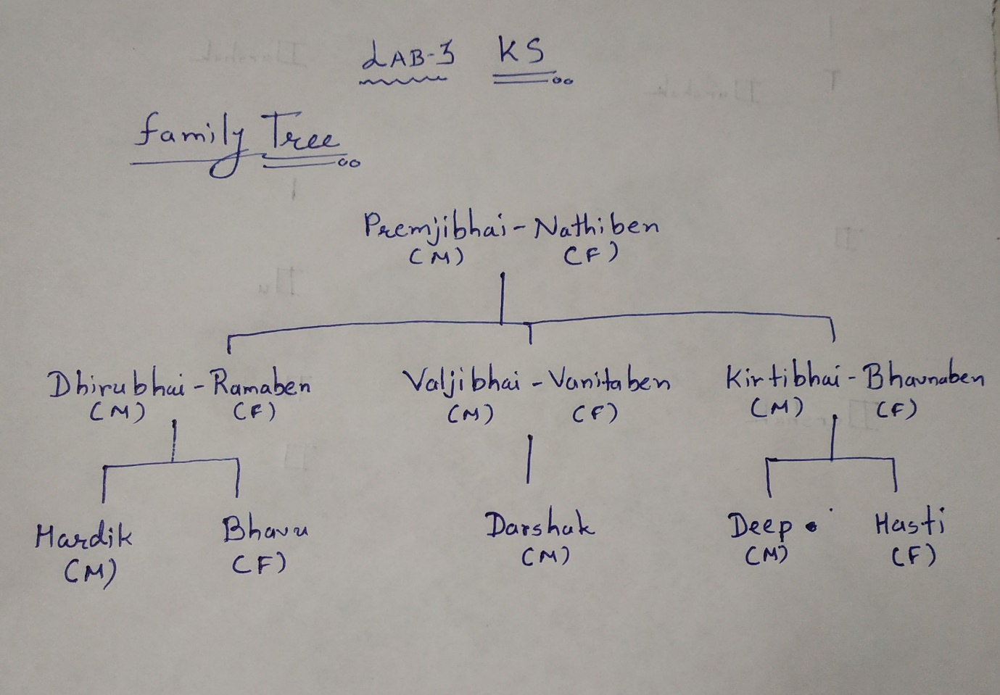

**Code:**

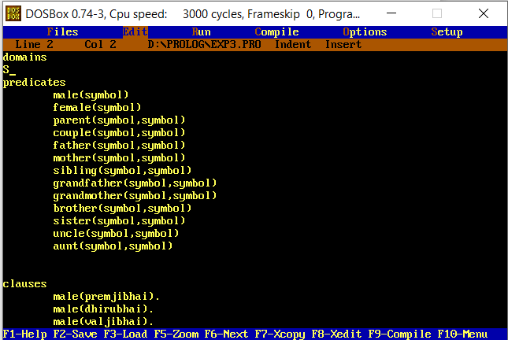

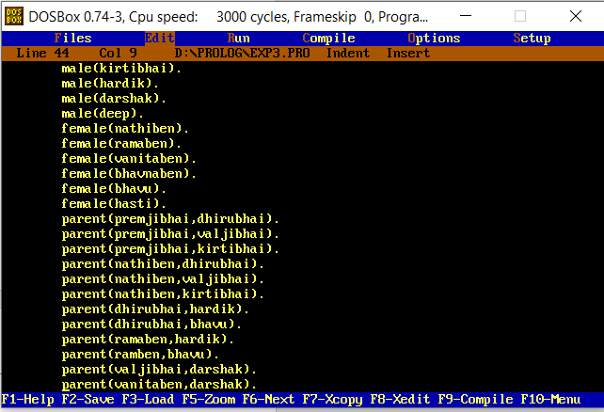

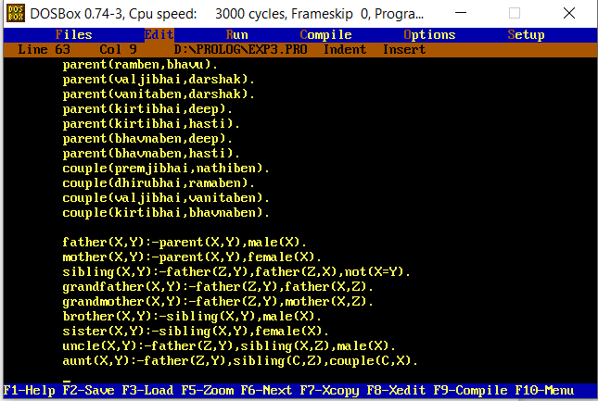

**Output:**

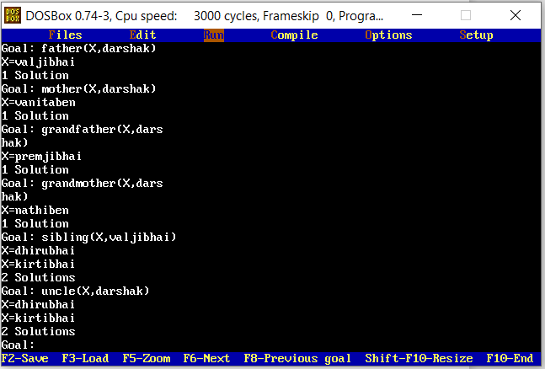

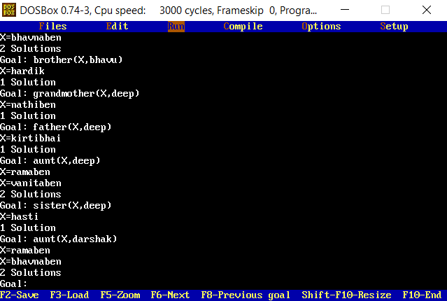

Code:

domains

predicates

male(symbol)

female(symbol)

parent(symbol,symbol)

couple(symbol,symbol)

father(symbol,symbol)

mother(symbol,symbol)

sibling(symbol,symbol)

grandfather(symbol,symbol)

grandmother(symbol,symbol)

brother(symbol,symbol)

sister(symbol,symbol)

uncle(symbol,symbol)

aunt(symbol,symbol)

clauses

male(premjibhai).

male(dhirubhai).

male(valjibhai).

male(kirtibhai).

male(hardik).

male(darshak).

male(deep).

female(nathiben).

female(ramaben).

female(vanitaben).

female(bhavnaben).

female(bhavu).

female(hasti).

parent(premjibhai,dhirubhai).

parent(premjibhai,valjibhai).

parent(premjibhai,kirtibhai).

parent(nathiben,dhirubhai).

parent(nathiben,valjibhai).

parent(nathiben,kirtibhai).

parent(dhirubhai,hardik).

parent(dhirubhai,bhavu).

parent(ramaben,hardik).

parent(ramben,bhavu).

parent(valjibhai,darshak).

parent(vanitaben,darshak).

parent(kirtibhai,deep).

parent(kirtibhai,hasti).

parent(bhavnaben,deep).

parent(bhavnaben,hasti).

couple(premjibhai,nathiben).

couple(dhirubhai,ramaben).

couple(valjibhai,vanitaben).

couple(kirtibhai,bhavnaben).

father(X,Y):-parent(X,Y),male(X).

mother(X,Y):-parent(X,Y),female(X).

sibling(X,Y):-father(Z,Y),father(Z,X),not(X=Y).

grandfather(X,Y):-father(Z,Y),father(X,Z).

grandmother(X,Y):-father(Z,Y),mother(X,Z).

brother(X,Y):-sibling(X,Y),male(X).

sister(X,Y):-sibling(X,Y),female(X).

uncle(X,Y):-father(Z,Y),sibling(X,Z),male(X).

aunt(X,Y):-father(Z,Y),sibling(C,Z),couple(C,X).